Weather Tracking app

jake kidder, solomon lin, david marben, ain yang

Team 37

MAY 29, 2016

User Guides

Version 1.0.0

**Contents**

1.0 Introduction and Purpose 2

2.0 Features 2

2.1 Platforms supported…………………………………………………………………………………………………………………2

2.2 Features of the app……………………….…………………………………………………………………………………………2

3.0 App Overview 2

3.1 Launch Page……………………………………………………………………………………………………………………………2

3.2 Add Location Page……………………………………………………………………………………………………………………2

3.1 View Location Page…………………………………………………………………………………………………………………2

4.0 Known Bugs or Limitation 2

4.1 Bugs…………………………………………………………………………………………………………………………………………2

4.1 Limitations………………………………………………………………………………………………………………………………2

# 1.0 Introduction and Purpose

This web app created by team 37 is a location and weather tracking app. The app can determine and show a location on a map based on a custom user-input. Further, the app will show weather details for the selected locations from the current day up until 30 days prior. The app can determine a location from anywhere across the globe using Google’s geocoding service as well as track weather details for that location using forecast.io as a resource.

The purpose of this app is to provide an accessible and user-friendly means of accessing weather details from any location on the planet. The specific features, how to use them, as well as current limitations of the app will also be explained later in the user guide.

# 2.0 Features

2.1 Platforms Supported:

This app is primarily meant to serve as a mobile web app on either an Android or Apple mobile phone. It can also be used on a laptop, however due to the in-built specifications the app performs best on mobile devices.

2.2 Features of the App:

* Location Tracking
* Daily weather reports (up to 30 days)
* ‘Favourite’ locations list
* Ability to add/ remove locations

# 

# 3.0 App Overview

**3.1 Launch Page**:

This is the page that the user will be presented with upon opening the app. The favourite locations list will show along with the title and ‘Add Location’ button as shown in the screenshot diagram below.

Title

Add Location Button

# 

Saved Location

Weather Summary

Weather Icon

The user can click on the ‘Add Location’ button (‘+’ icon) to proceed to the add location screen. The user could also click on a saved location in the locations list to go to the view location screen as shown below.

**3.2 Add Location Page:**

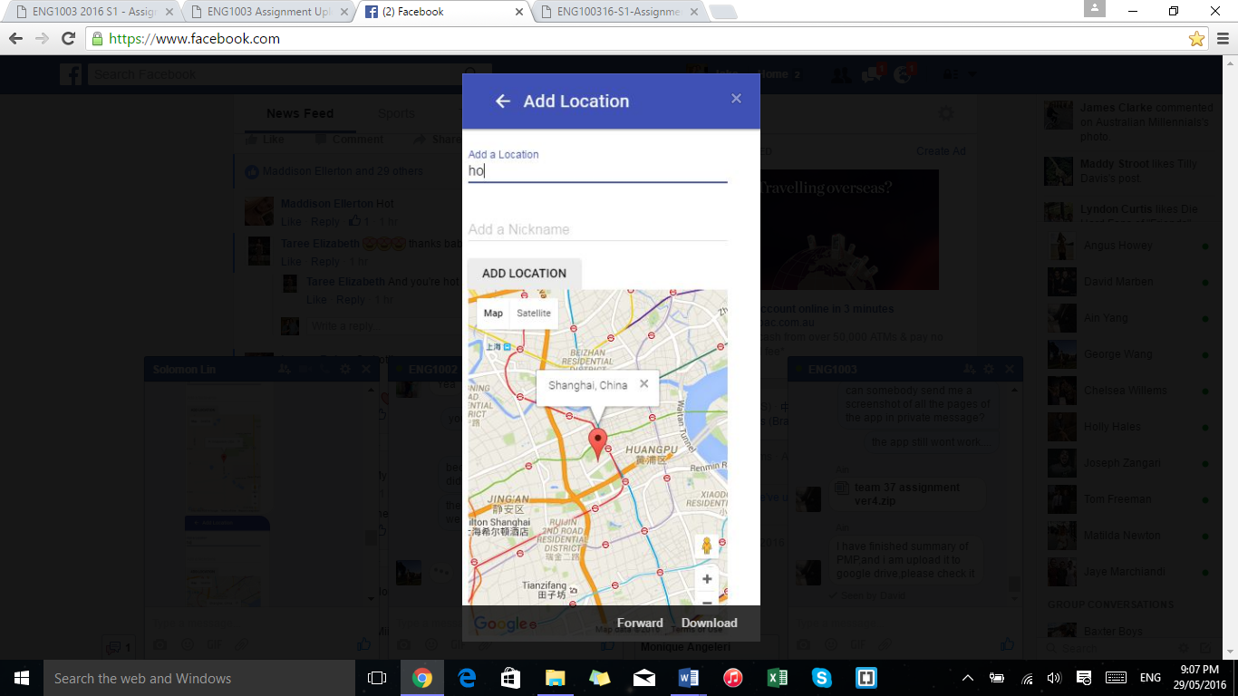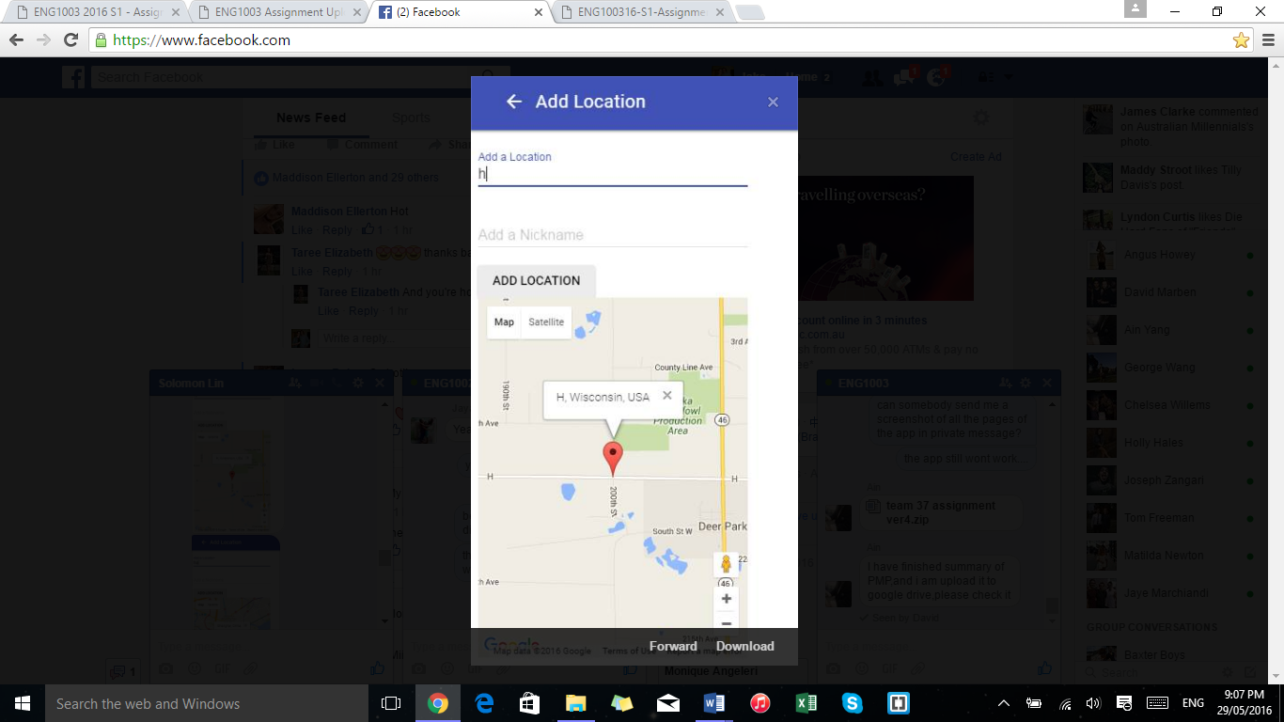

Input Boxes

Add Location Button

Info Window

Marker

Map

# The add location page allows the user to input a favourite location to save to the locations list. This screen has two input boxes. The ‘add a location’ box allows the user to type the address that they wish to search. The ‘add a nickname’ box allows the user to assign a nickname to the location that they have selected. Once the user has filled out the two input boxes they must press the ‘Add Location’ button for the location to be saved into the locations list.

The ‘add a location’ input box updates the map to show the location after each character change in the input box. This is shown by the difference in the two screenshots above. Further, the input box allows the address to be input in multiple ways such as ‘23 Watts Street’, or ‘Melbourne, VIC’. This provides a more user-friendly experience with the app.

**3.3 View Location Page:**

The third and final screen that the user will encounter is the ‘view location’ screen as shown below.

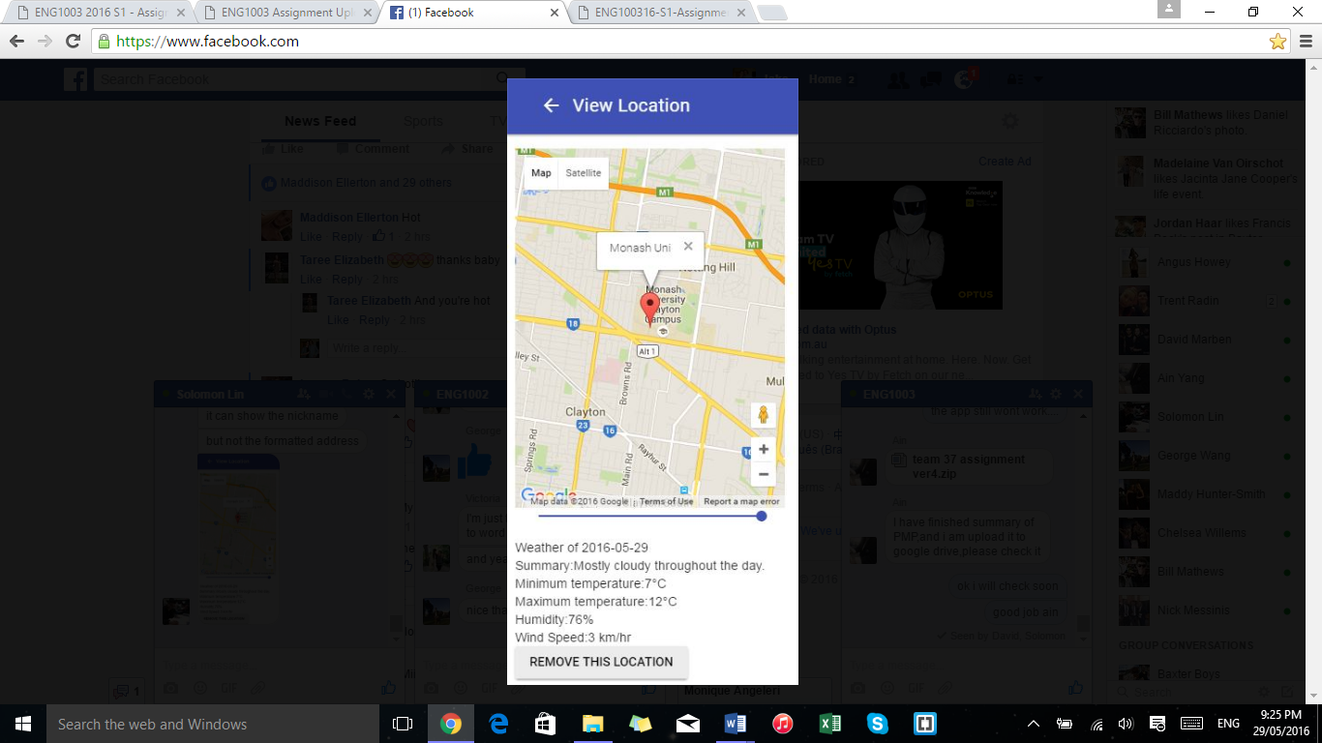

Slider

Map

Weather Summary

Remove Location Button

Info Window

Marker

# This screen shows the location selected by the user from the locations list on the launch page. The user’s saved location will show on the map with a marker and info window that displays the user’s nickname for the location. The app provides a slider under the map that allows the user to change the weather summary from the current day to the weather for 30 days ago. Further, below the map is a summary of weather details provided from the current day up until the past 30 days. Finally, there is a ‘remove this location’ button as shown on the screenshot diagram above that allows the user to remove the location from their saved locations list.

# 4.0 Known Bugs or Limitation

The app currently has multiple bugs and limitations that are able to be fixed but were not able to be before the deadline.

**4.1 Bugs:**

*Location saved for each character input:* A current bug within the app is that it will create a saved location for each character that is put into the ‘add a location’ input box on the Add Location page.

*Nickname required:* If there is no input in the ‘add a nickname’ input box then the app will not show a name for that location on the locations list.

The above two bugs are shown on the following screenshot where ‘Vic’ was searched but no nickname was entered. The resulting locations list is as follows:

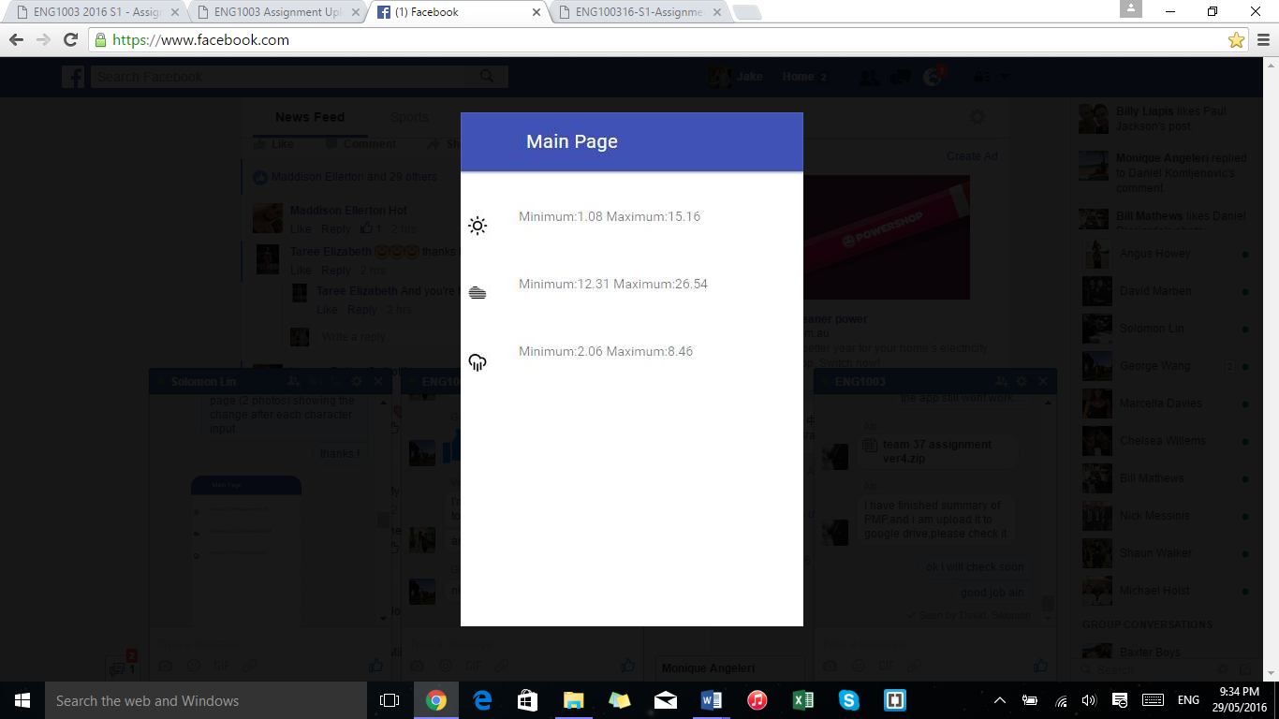

*Weather icons:* The app is designed to display weather icons next to each location in the location list. However, sometimes the app fails to load these icons.

**4.2 Limitations:**

*Daily weather updates:* Currently the app only shows daily weather updates for the selected locations. Future versions of the app may display hourly or even minutely weather updates with an additional slider on the ‘View Location’ screen.

*No future weather details:* Currently the app only shows weather for the current day and 30 days in the past. Future versions of the app could include a seven day forecast for the selected location as well as an extended past weather details list.